|  |
| --- |
| EPAM Systems, RD Dep.  MTN.*NIX.07 Oracle DB. Introduction to DWH |
| MTN.*NIX.07 Labs - Access and Join Methods Part 2 |

|  |  |  |  |  |  |
| --- | --- | --- | --- | --- | --- |
| REVISION HISTORY | | | | | |
| Ver. | Description of Change | Author | Date | Approved | |
| Name | Effective Date |
| 1.0 | Initial status of document | [**Kiryl Bucha**](mailto:Kiryl_bucha@epam.com) | 16-JAN-2012 |  |  |
|  |  |  |  |  |  |

*Contents*

1. Auto Trace & Explain Plan 3

1.1. Task 1: Auto Trace configuration training 3

2. Join Methods 3

2.1. Task 2: Nested Loops Joins 4

2.2. Task 3: Sort-Merge Joins 4

2.3. Task 4: Hash Joins 4

2.4. Task 5: Cartesian Joins 4

2.5. Task 6: Left/Right Outer Joins 4

2.6. Task 7: Full Outer Join 4

2.7. Task 8: Semi Joins 4

2.8. Task 9: Anti Joins 5

2.9. Task 10: Prepare summary table 5

# Auto Trace & Explain Plan

## Task 1: Auto Trace configuration training

|  |  |  |  |
| --- | --- | --- | --- |
| № | Auto Trace Configuration Options | Expected Results | Description |
|  | set autotrace off | No AUTOTRACE report is generated |  |
|  | set autotrace on | The AUTOTRACE report includes both the optimizer execution path and the SQL statement execution statistics |  |
|  | set autotrace traceonly | Like SET AUTOTRACE ON, but suppresses the printing of the user's query  output, if any |  |
|  | set autotrace on explain | The AUTOTRACE report shows only the optimizer execution path. |  |
|  | set autotrace on statistics | The AUTOTRACE report shows only the SQL statement execution  statistics. |  |

# Join Methods

## Task 2: Nested Loops Joins

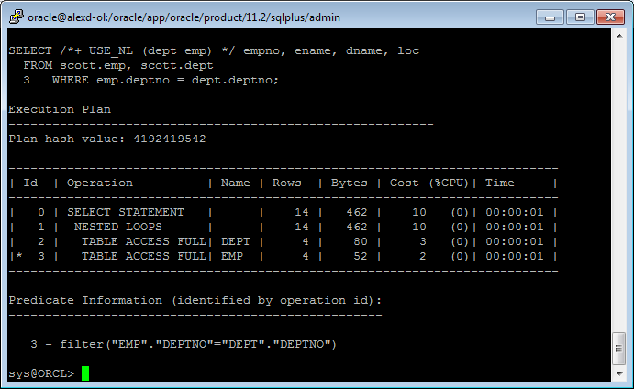

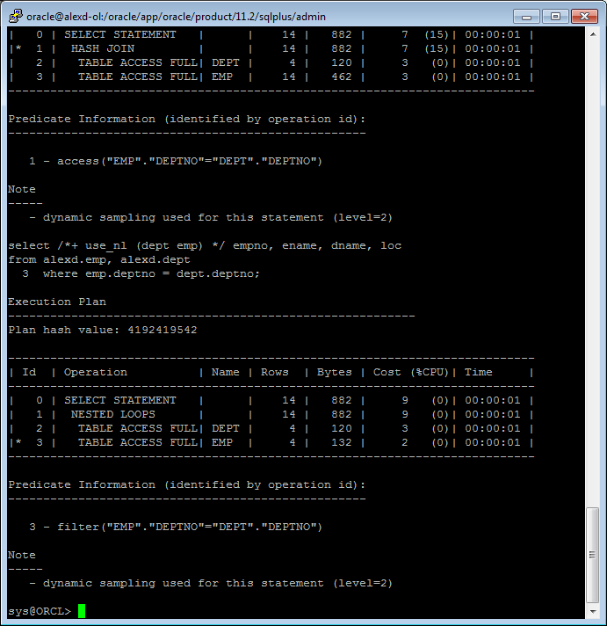

## Task 3: Sort-Merge Joins

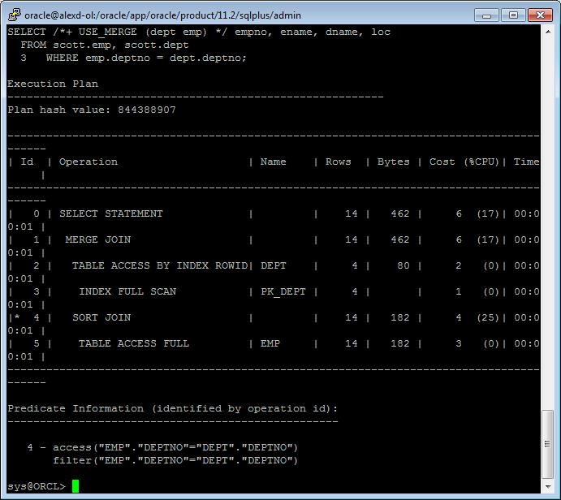

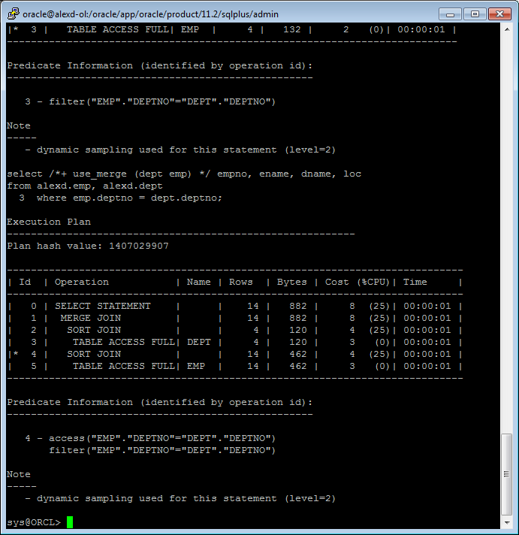

## Task 4: Hash Joins

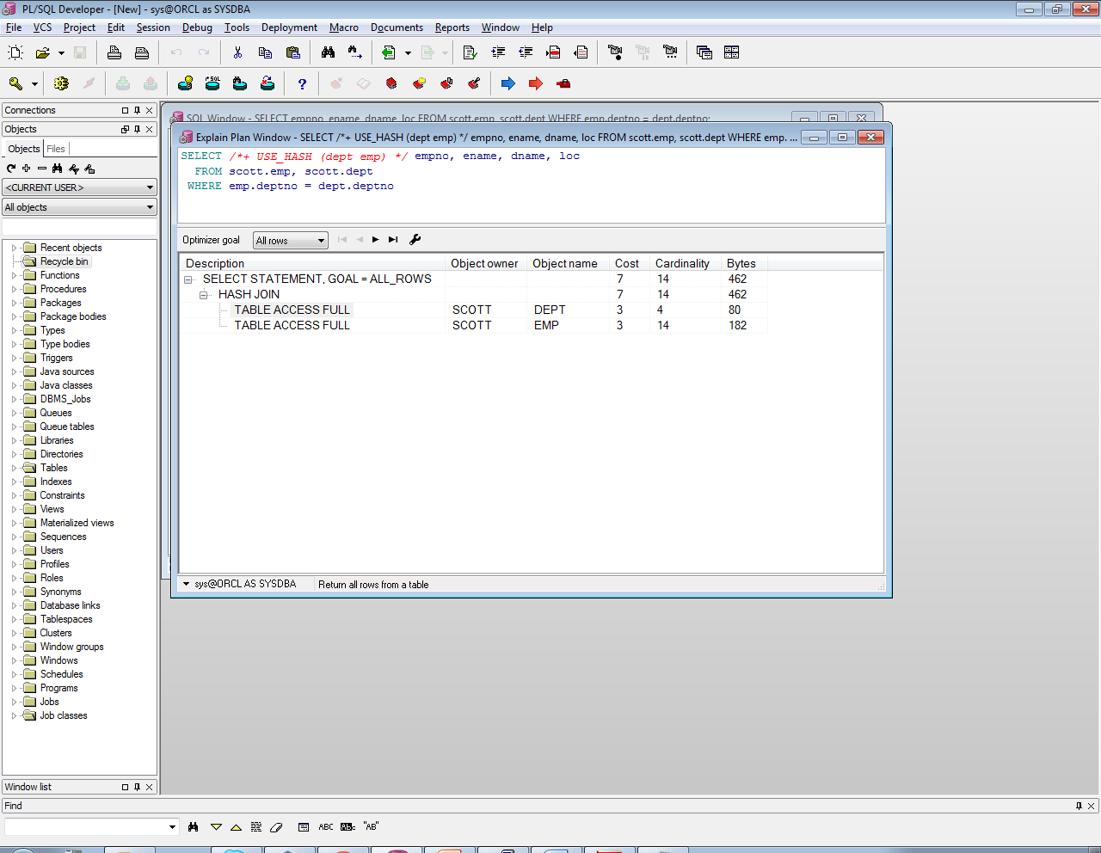

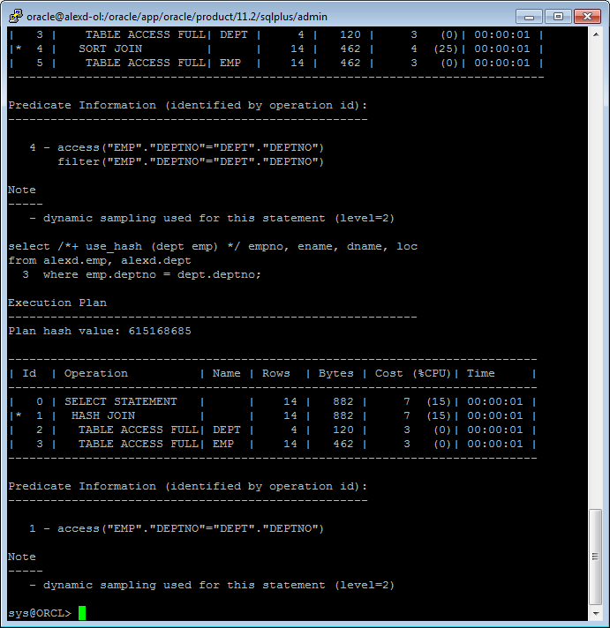

## Task 5: Cartesian Joins

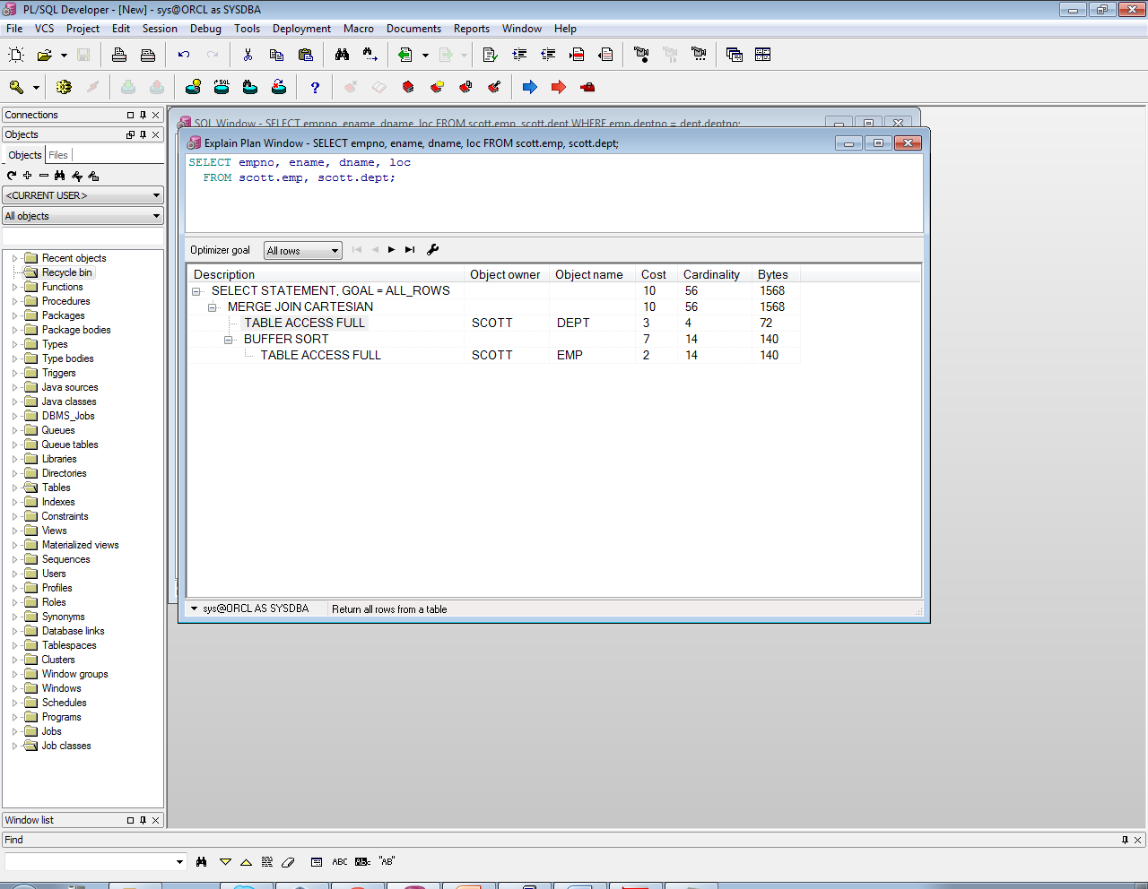

## Task 6: Left/Right Outer Joins

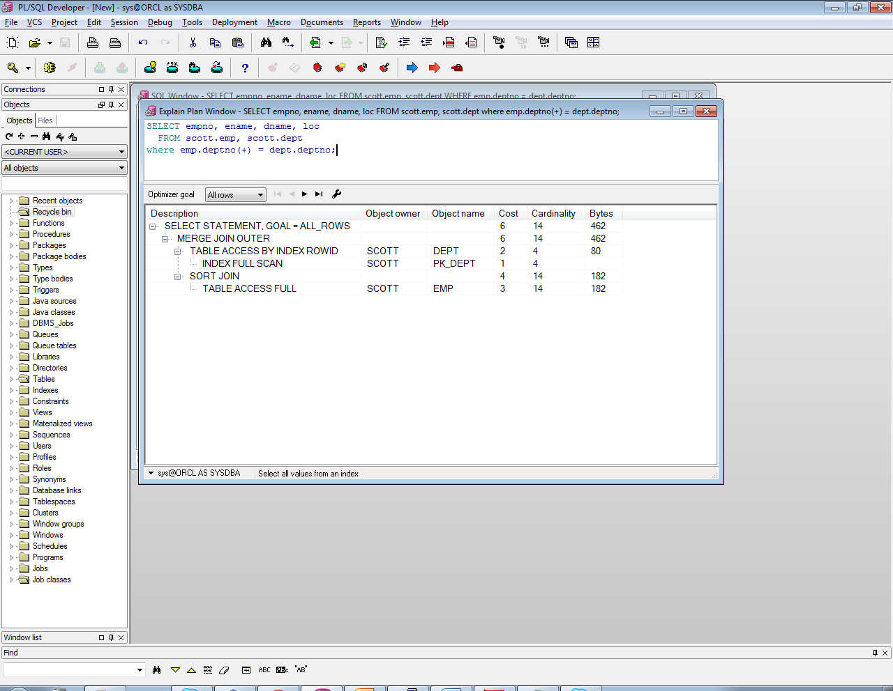

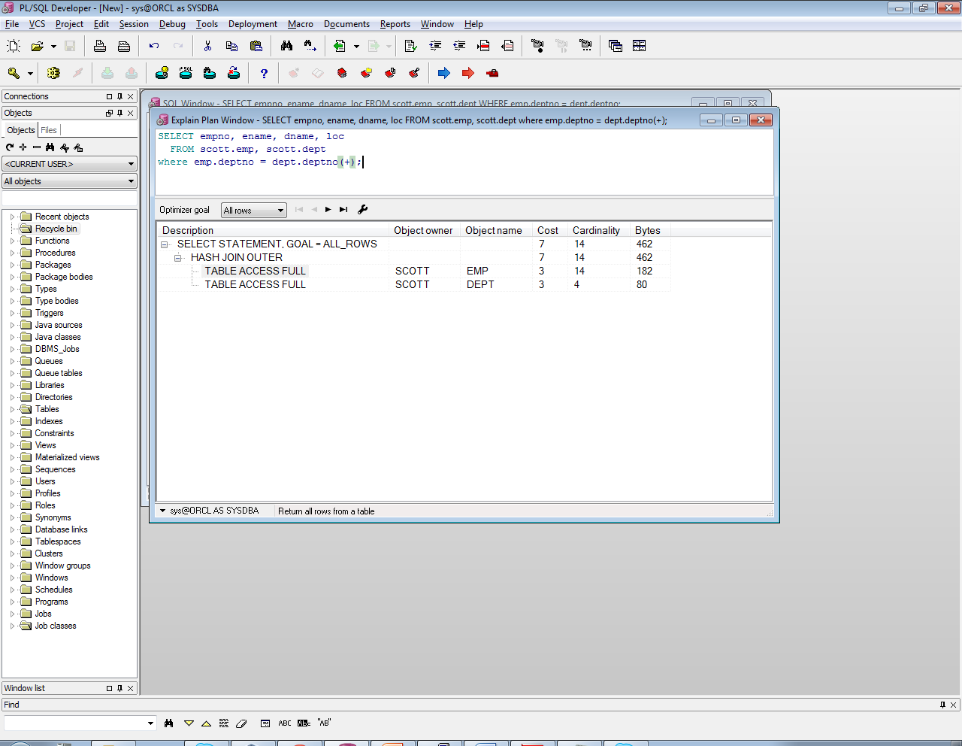

## Task 7: Full Outer Join

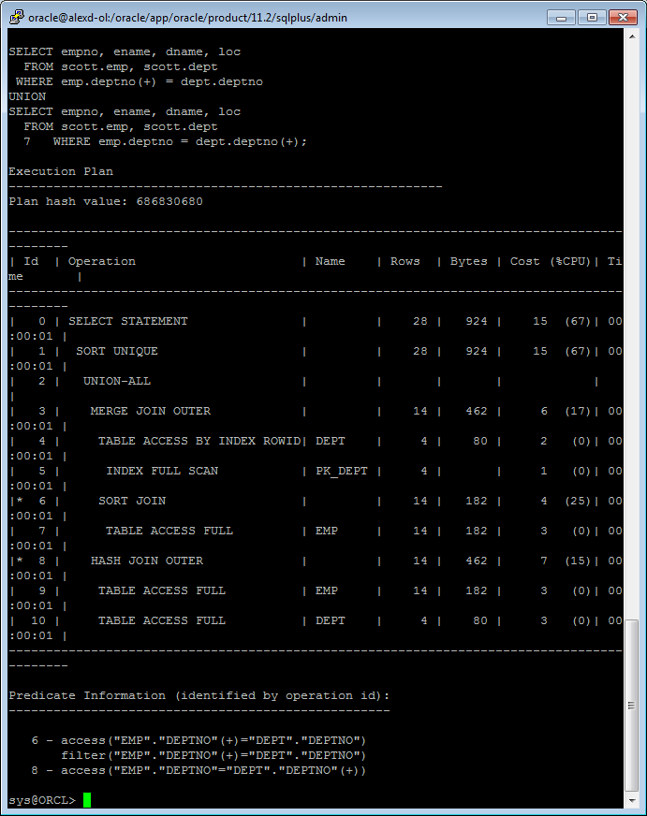

## Task 8: Semi Joins

1. SEMIJOIN – perform a semi-join (the optimizer gets to pick which kind)

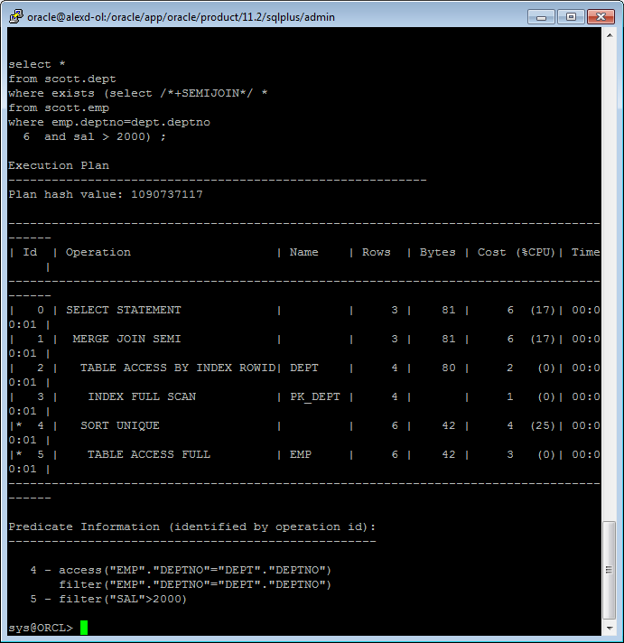

1. NO_SEMIJOIN – obviously means don’t perform a semi-join

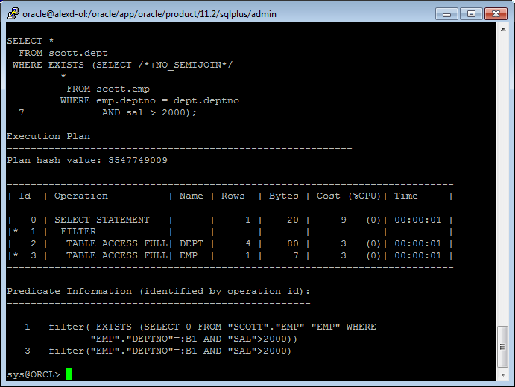

1. NL_SJ – perform a nested loops semi-join (deprecated as of 10g)

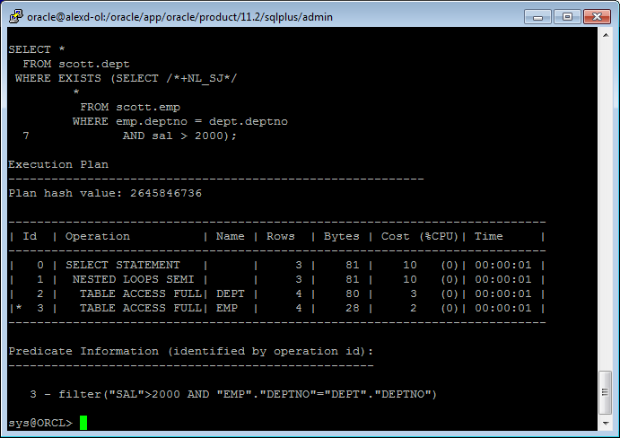

1. HASH_SJ – perform a hash semi-join (deprecated as of 10g)

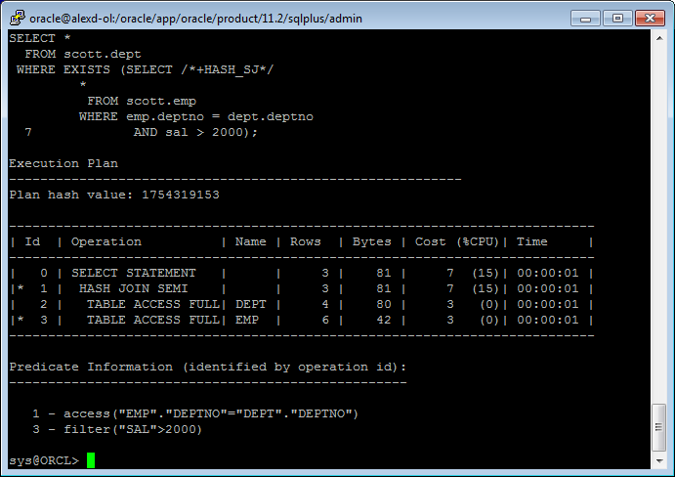

1. MERGE_SJ – perform a merge semi-join (deprecated as of 10g)

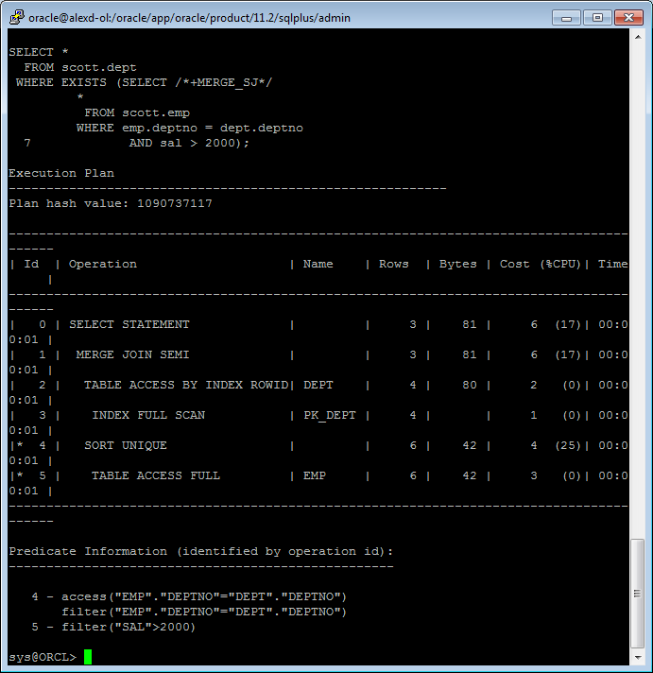

## Task 9: Anti Joins

1. ANTIJOIN – perform an anti-join (the optimizer gets to pick which kind)

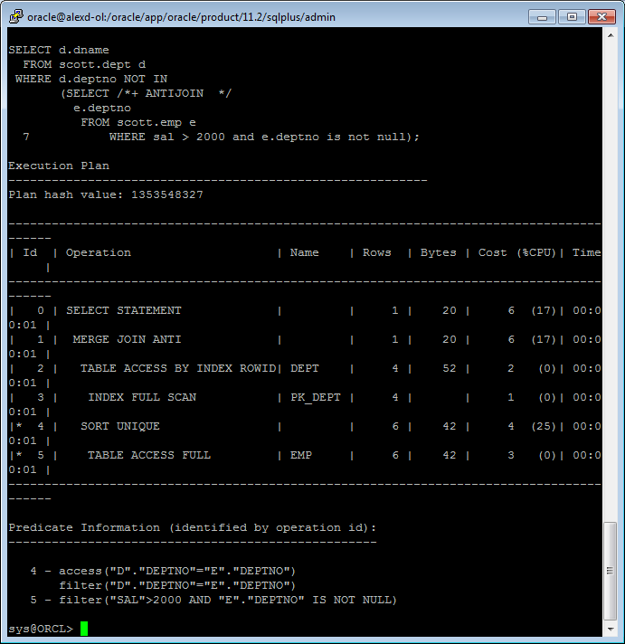

1. NL_AJ – perform a NESTED LOOPS anti-join (deprecated as of 10g)

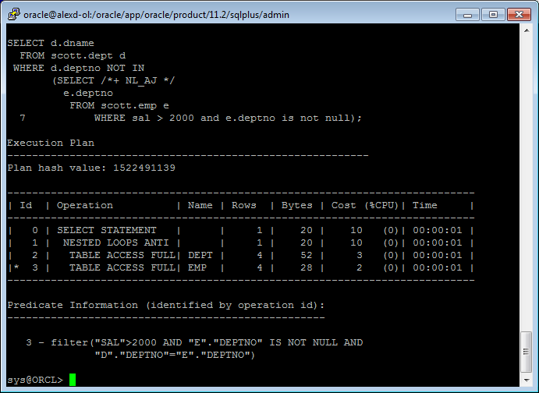

1. HASH_AJ – perform a HASH anti-join (deprecated as of 10g)

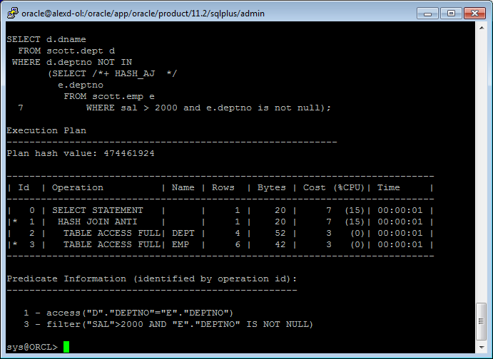

1. MERGE_AJ – perform a MERGE anti-join (deprecated as of 10g)

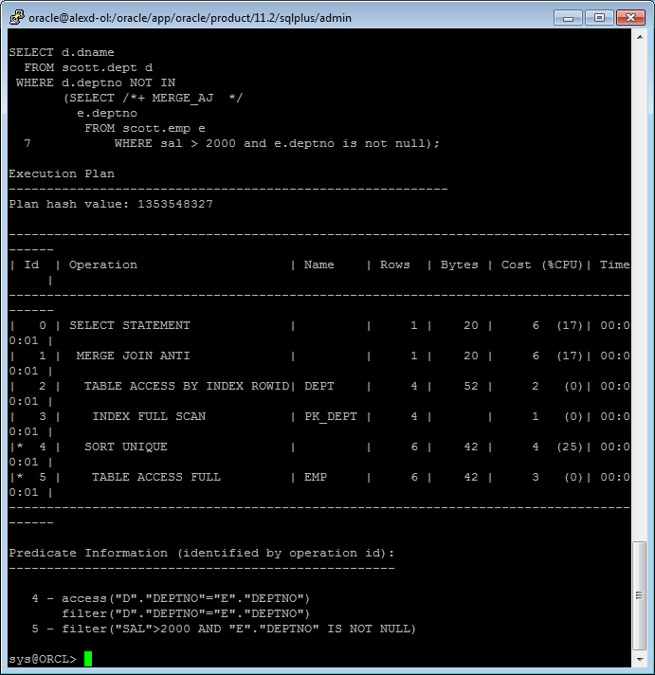

## Task 10: Prepare summary table

**Task:** Make comparison of all possible variant of join methods and join access methods and fill the table below:

|  |  |  |  |  |
| --- | --- | --- | --- | --- |
| Join Access “A” | Join Access “B” | Nested Loop | Hash Join | Sort-Merge Join |
| Small Table | Small Table | 23 | 20 | 30 |
| Small Table | Indexed Small Table | 25 | 20 | 22 |
| … |  |  |  |  |